**Clients & Servers**

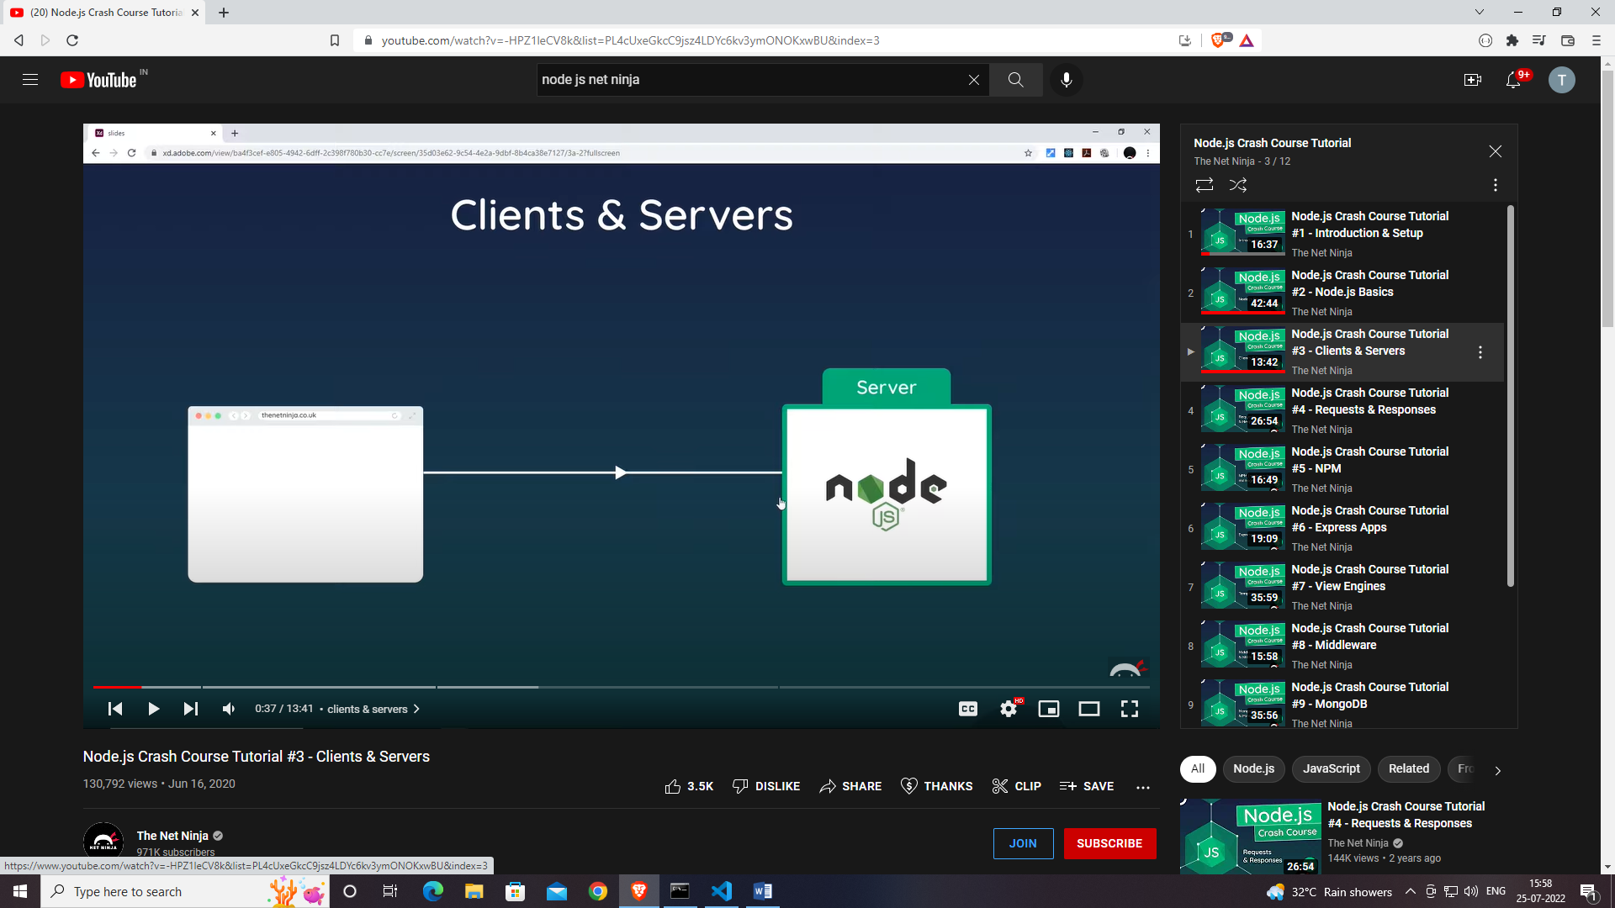

**IP Addresses**

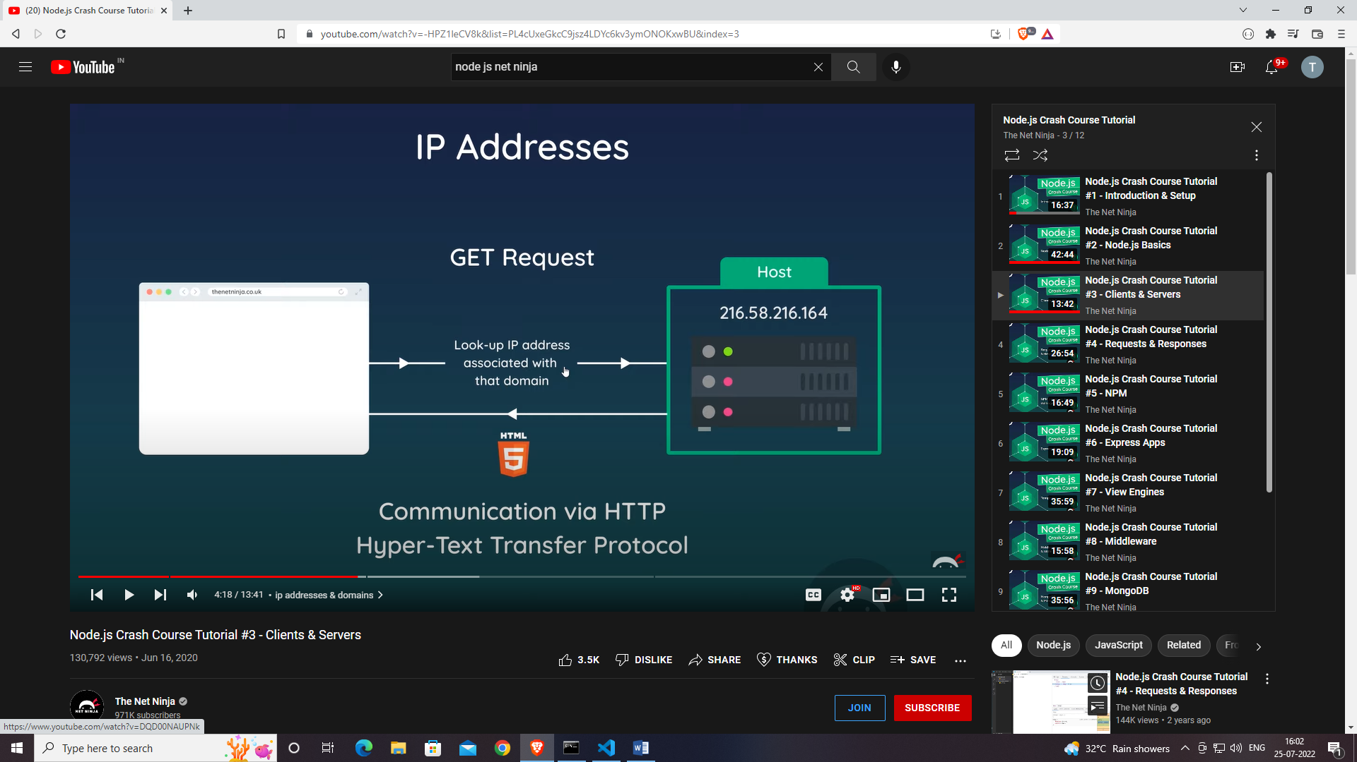

**Localhost & Port Number**

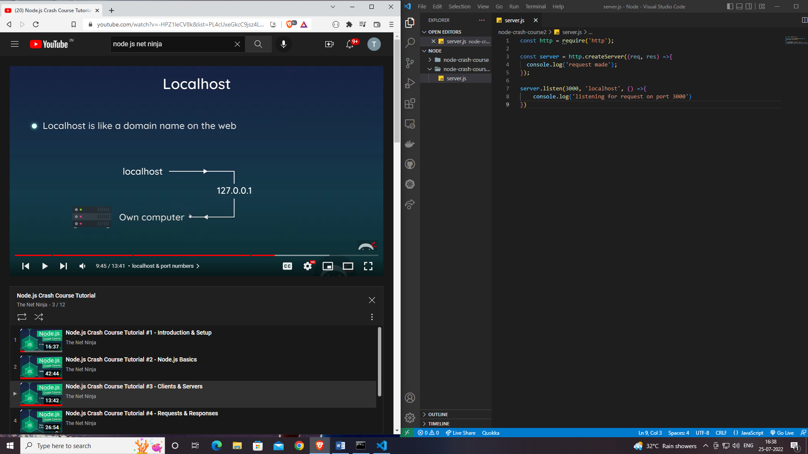

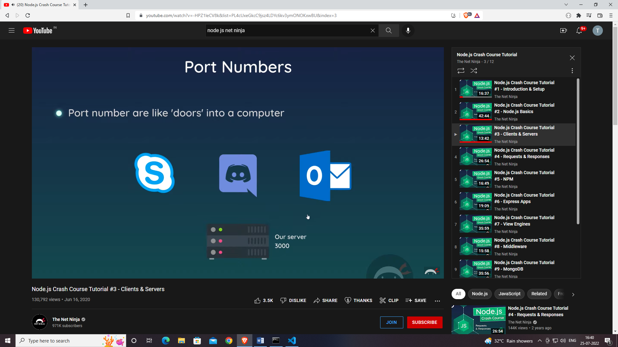

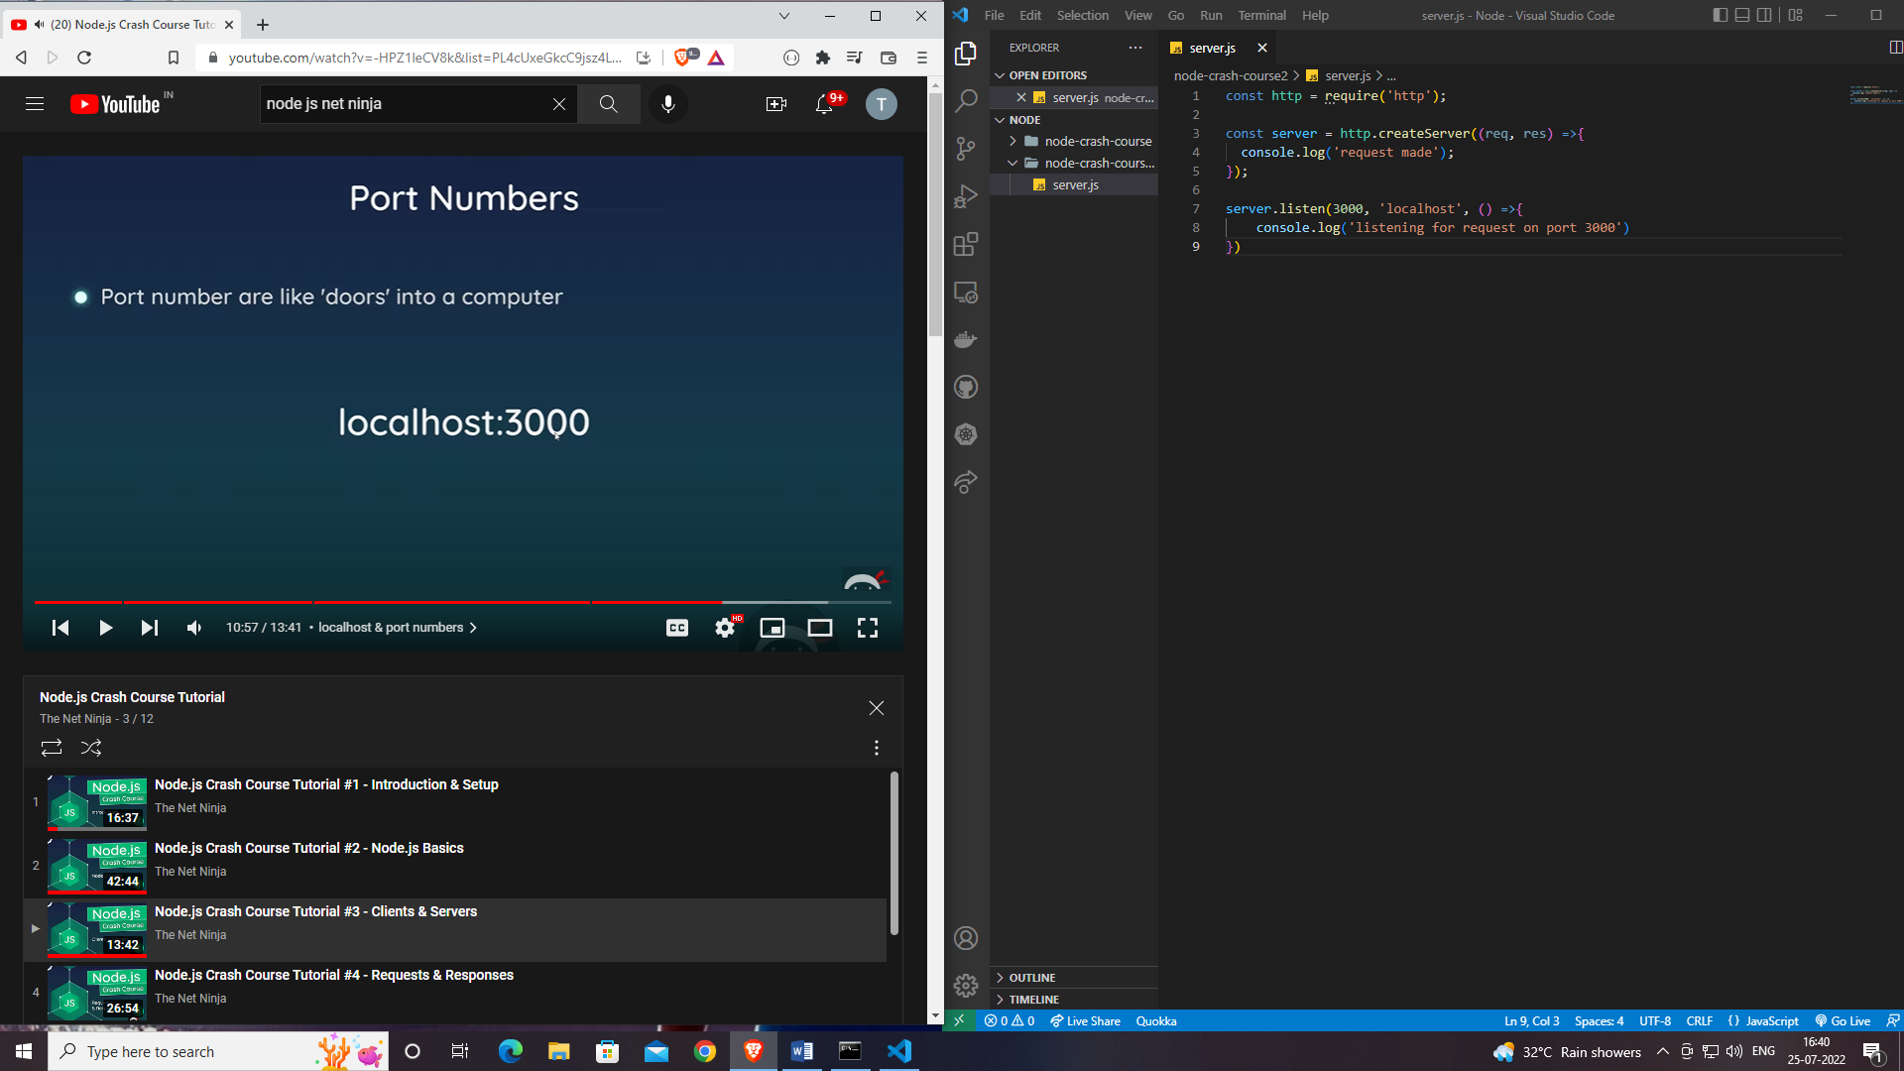

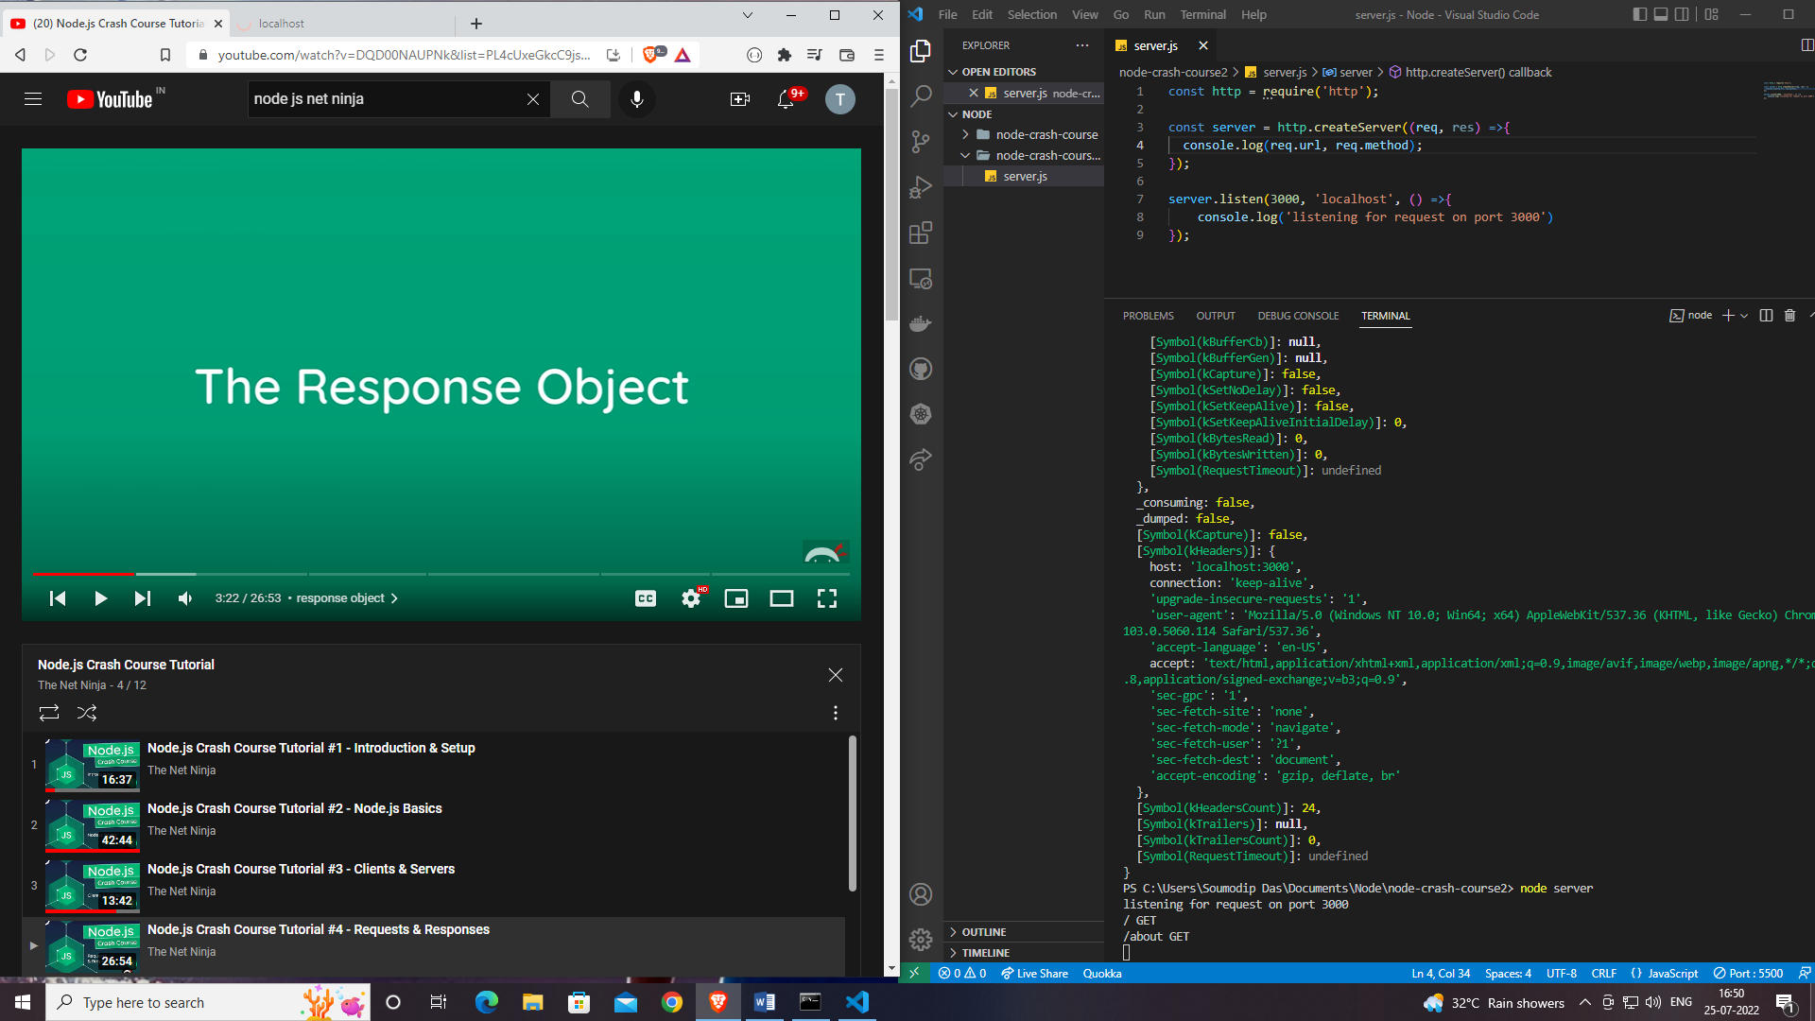

**The Response Object**

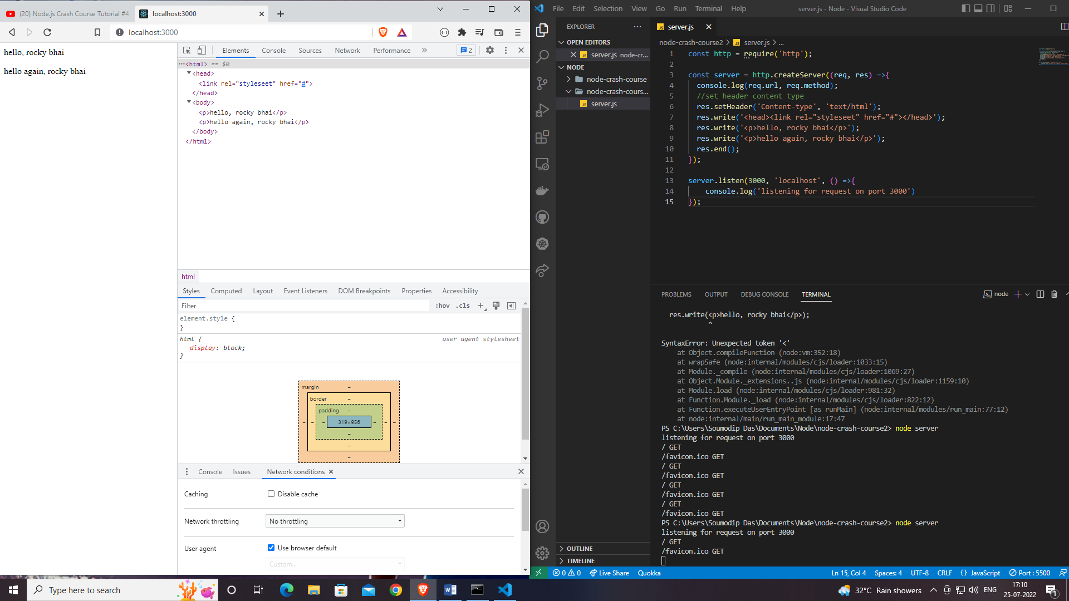

**Returning HTML Pages**

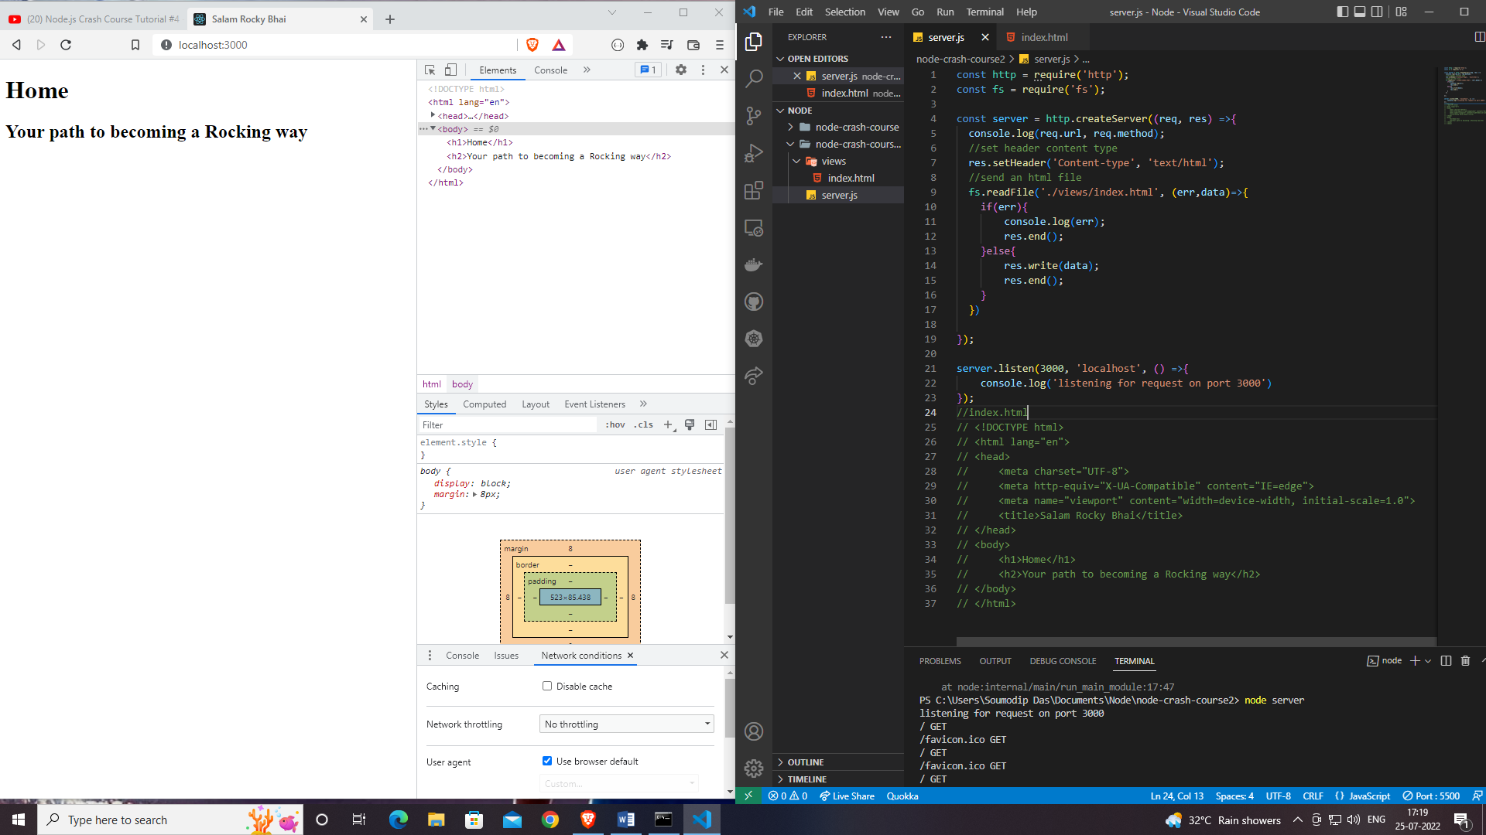

**OR**

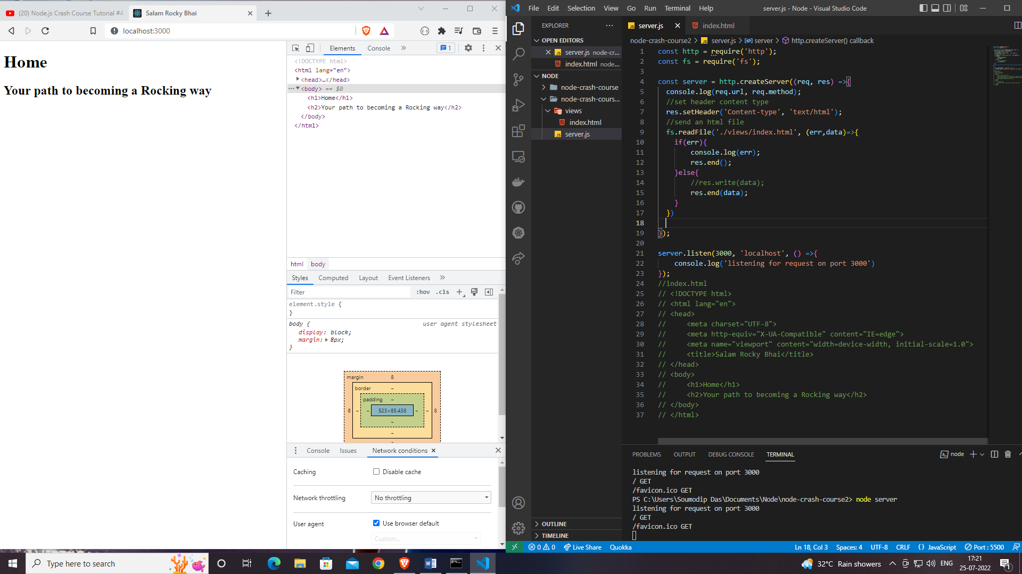

**Basic Routing**

## Home.html

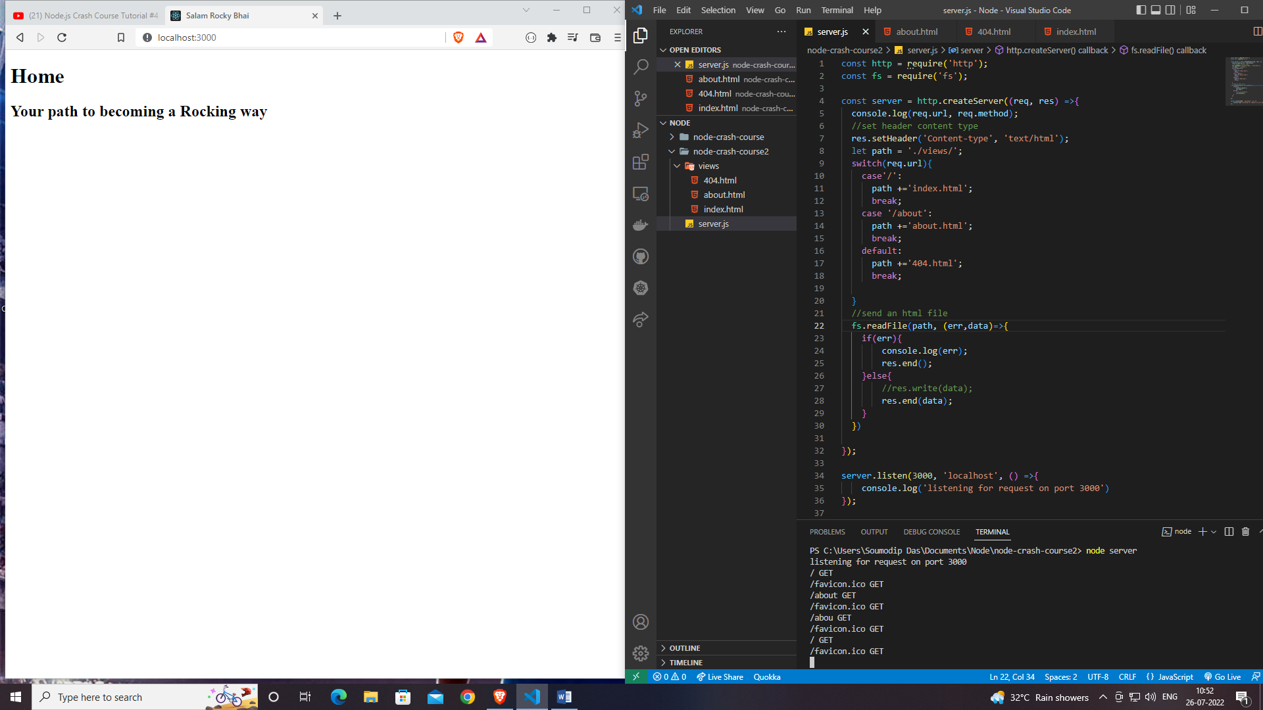

## About.html

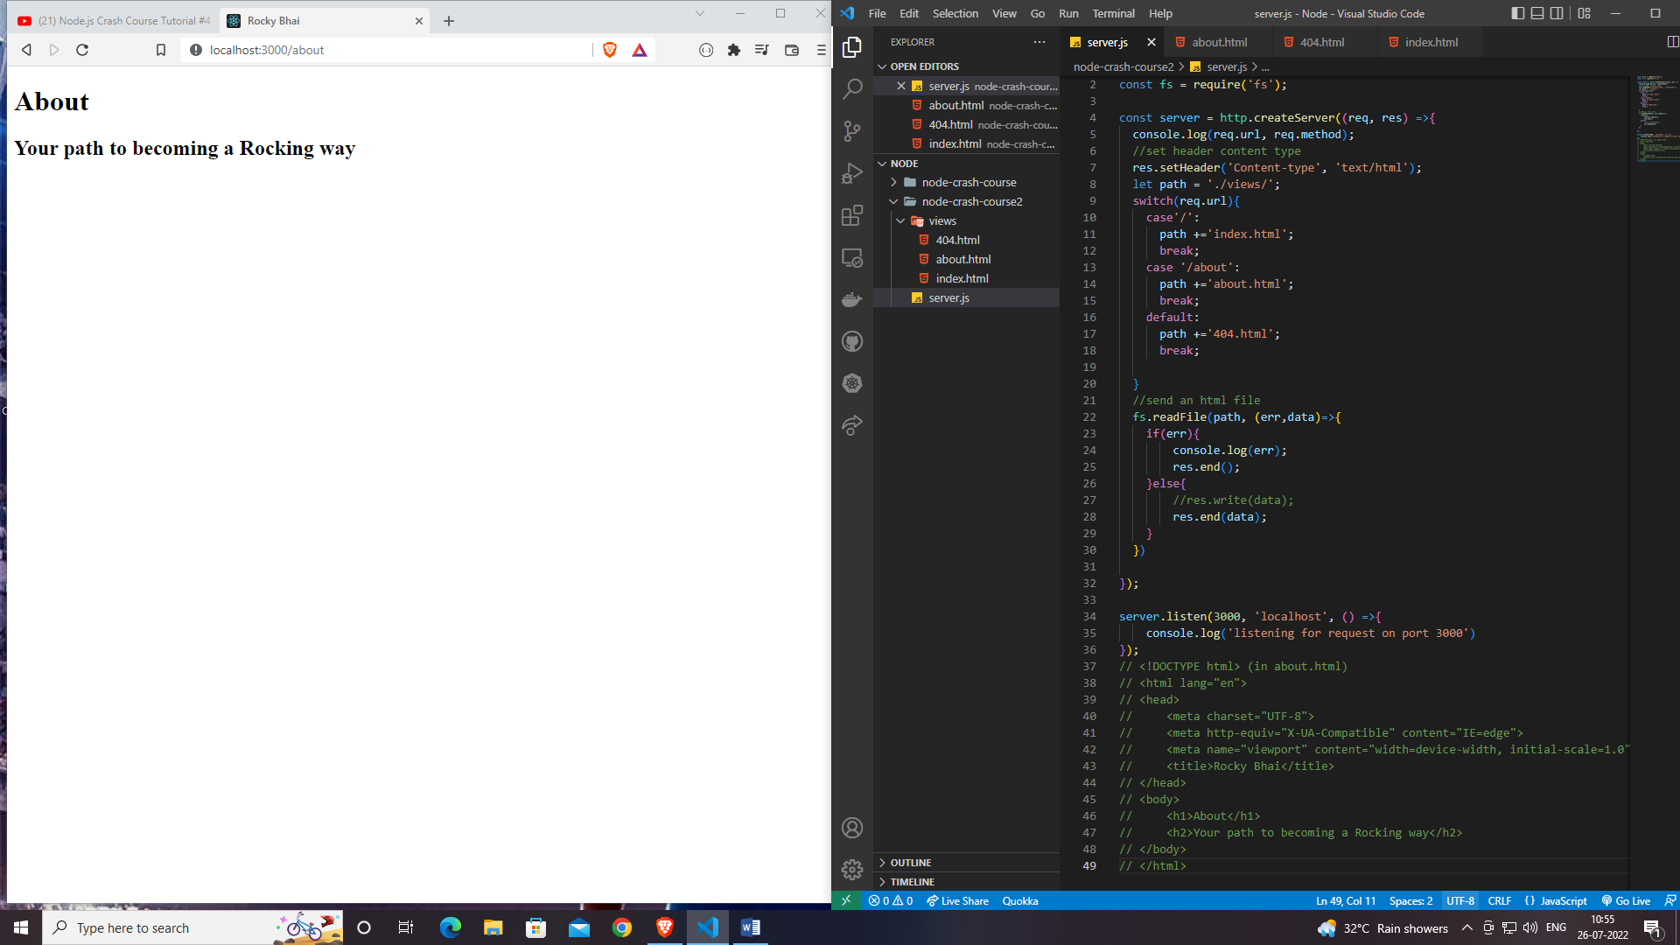

## 404.html

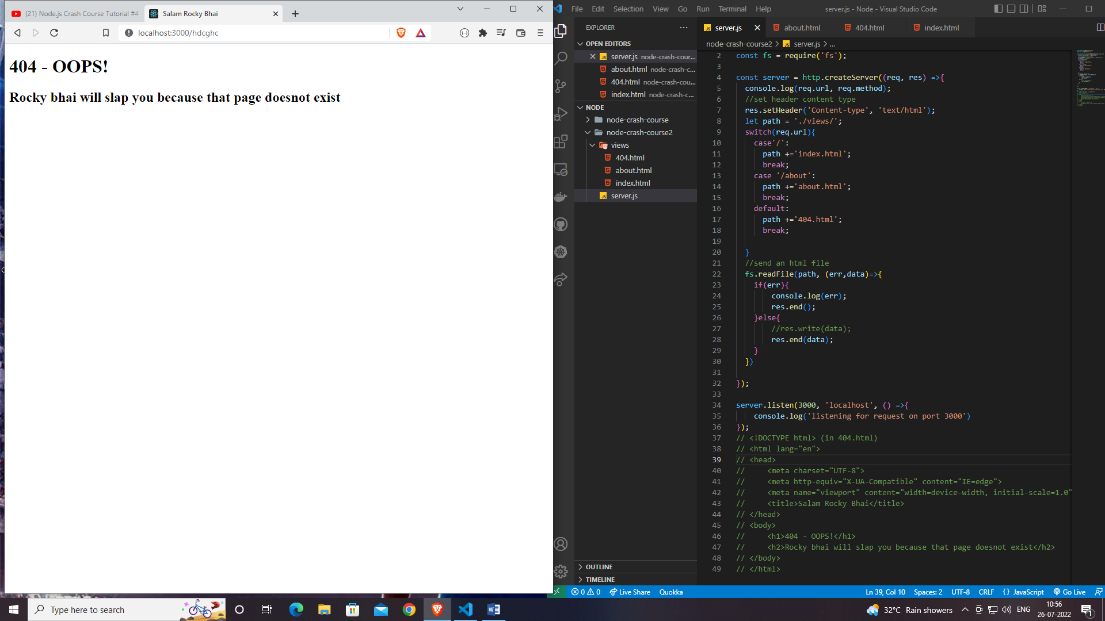

**Status Codes**

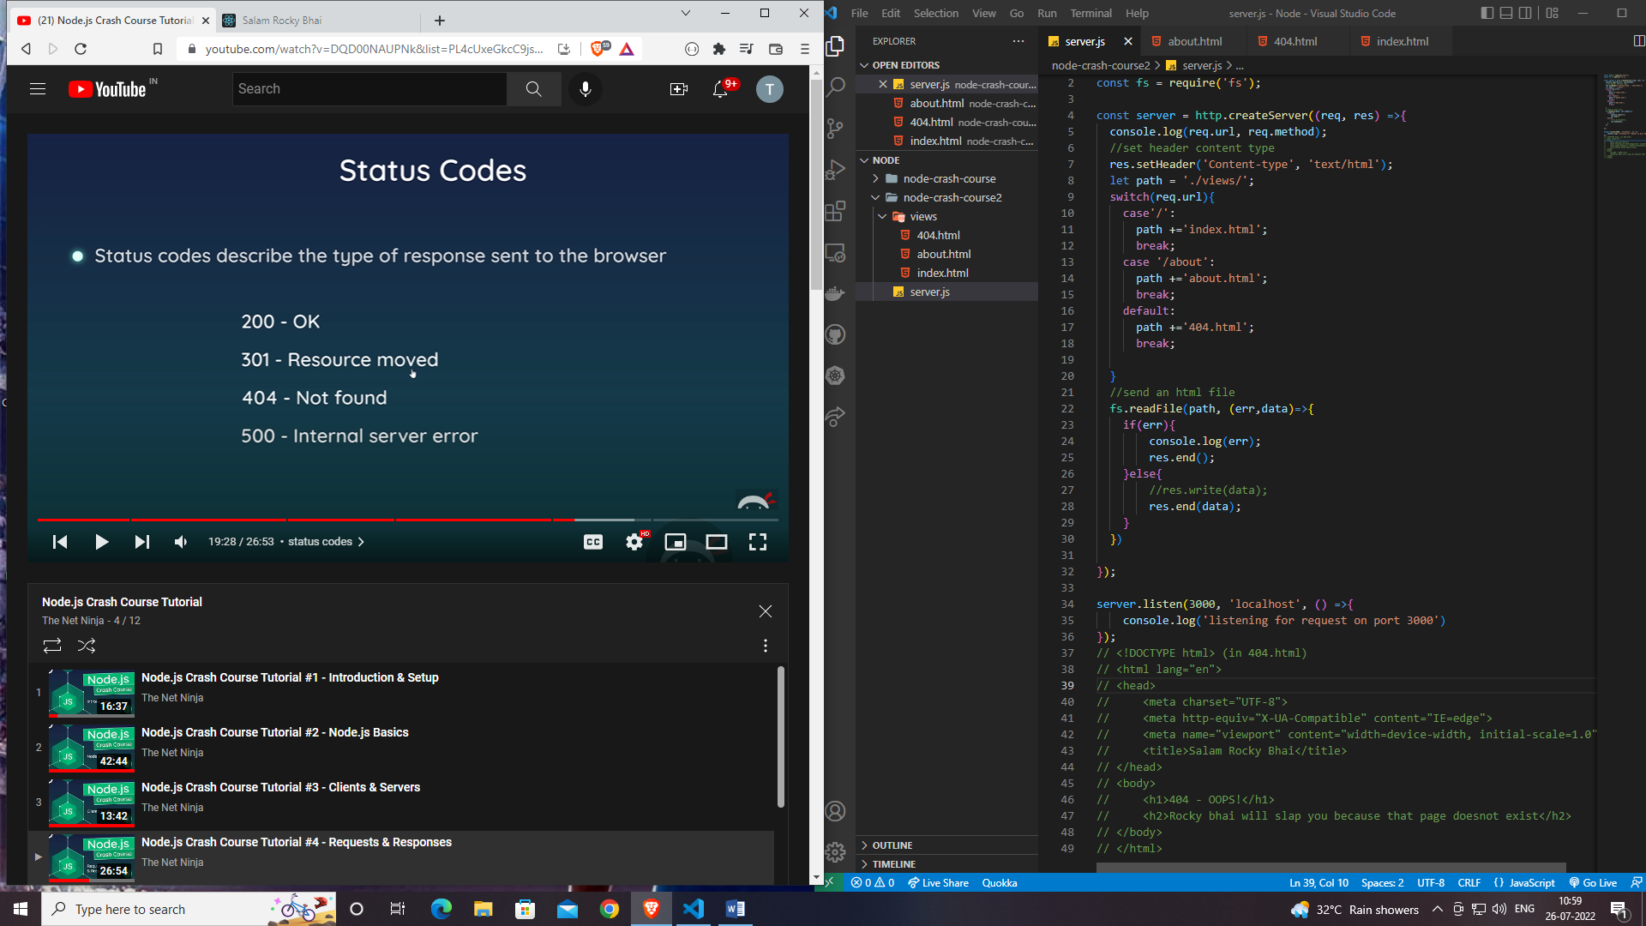

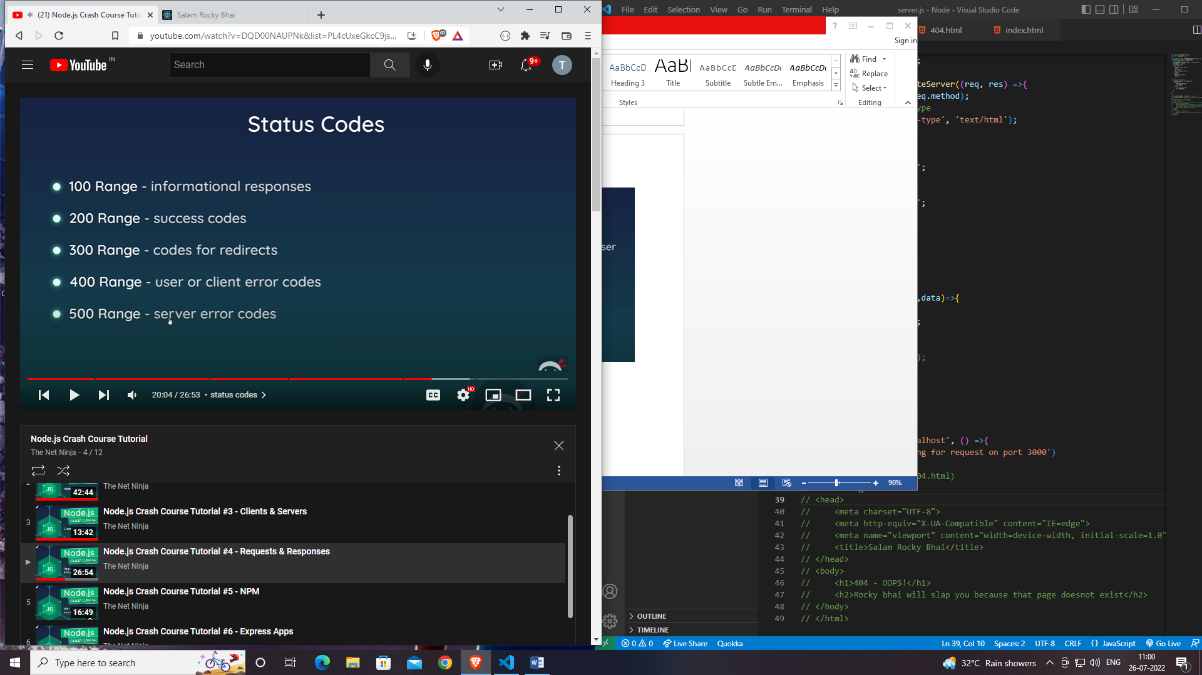

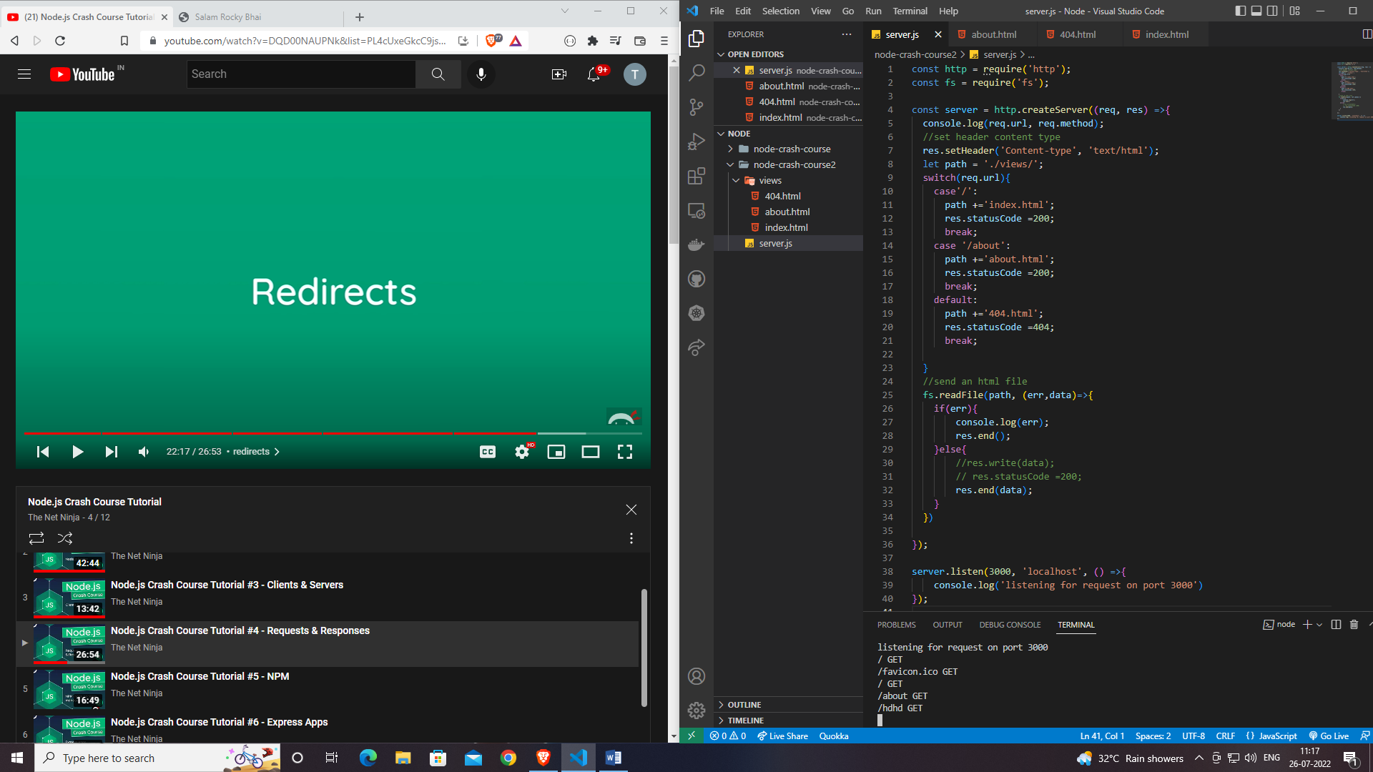

**Redirects**

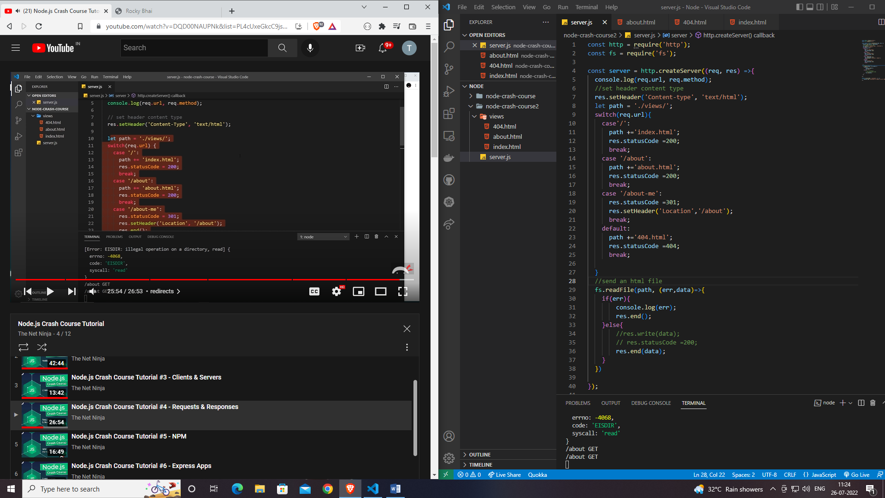

* **It redirects on a better way(about-me = about)**

**NPM = Node Package Manager**

* **Nodemon**

**When we are changing anything in code then we need to restart the servers manually, Nodemon help us to combat that by automatically restarting the server whenever changes are made and saved to our file.**

**So we have to install Nodemon.**

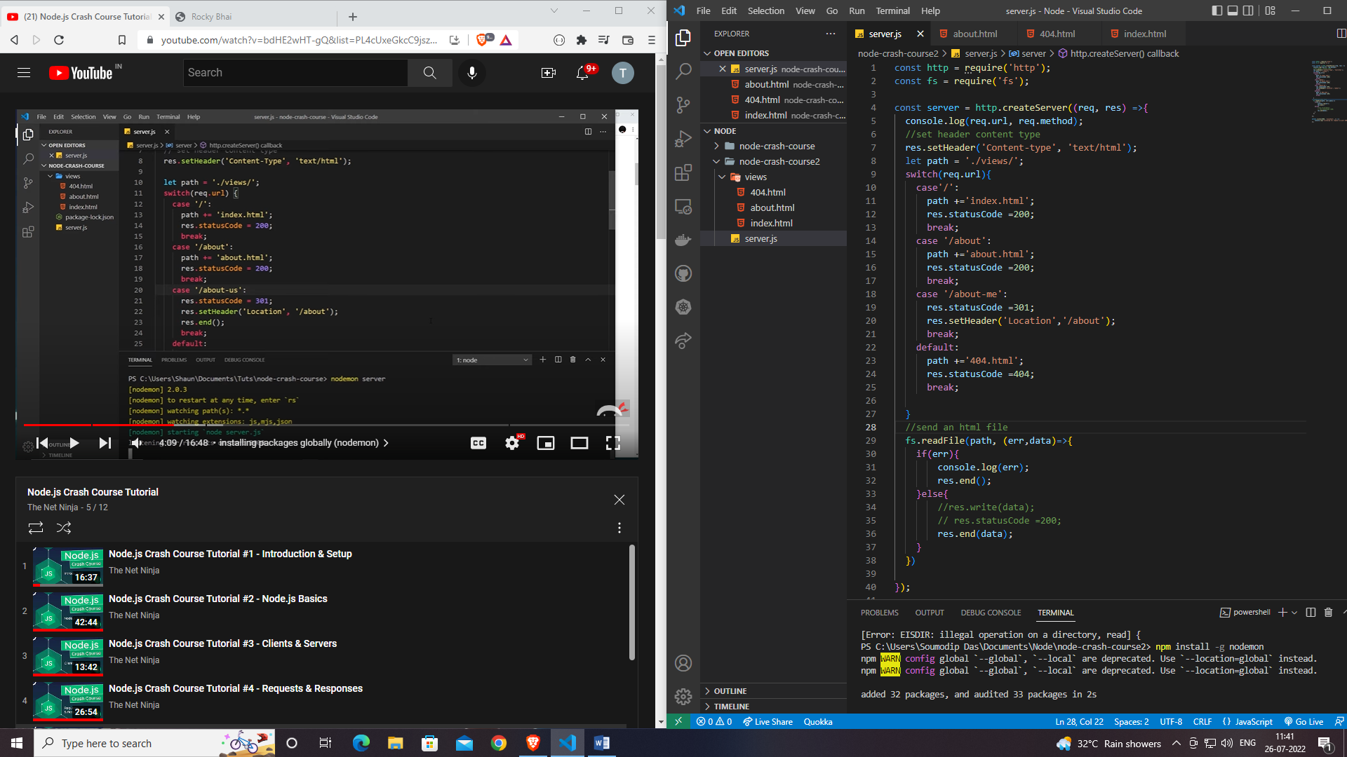

For install Nodemon in our system globally

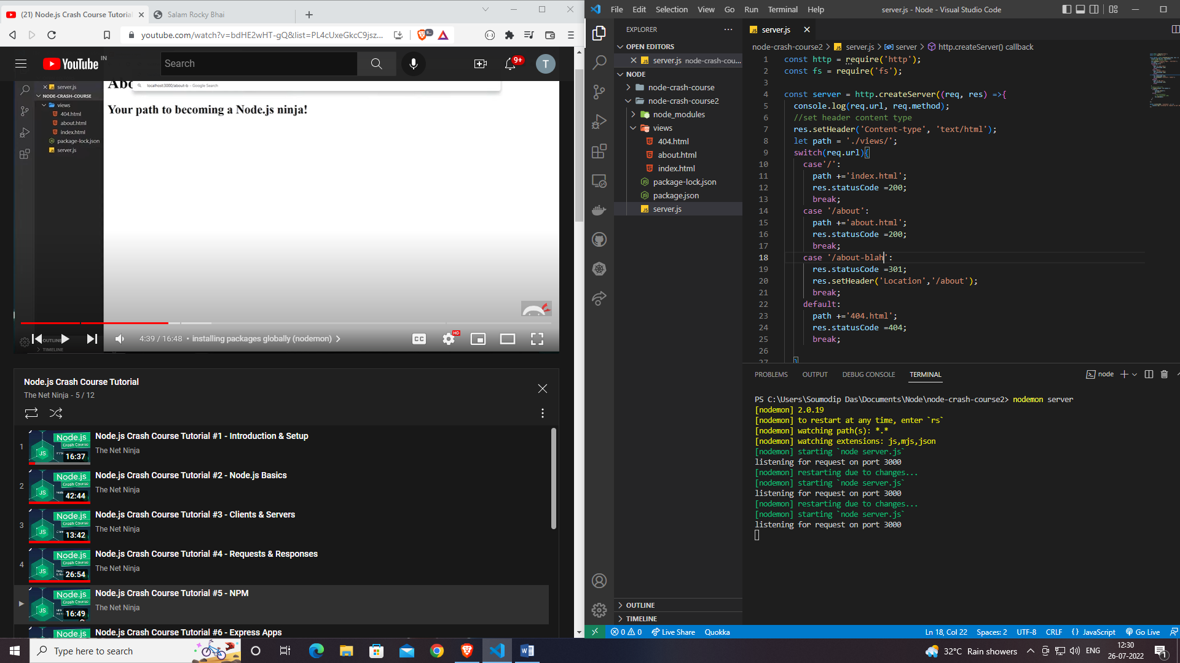

**It manually restart the server when we change the code.**

**Package.json File**

* **npm init for installing package.json file**

**Installing package locally**

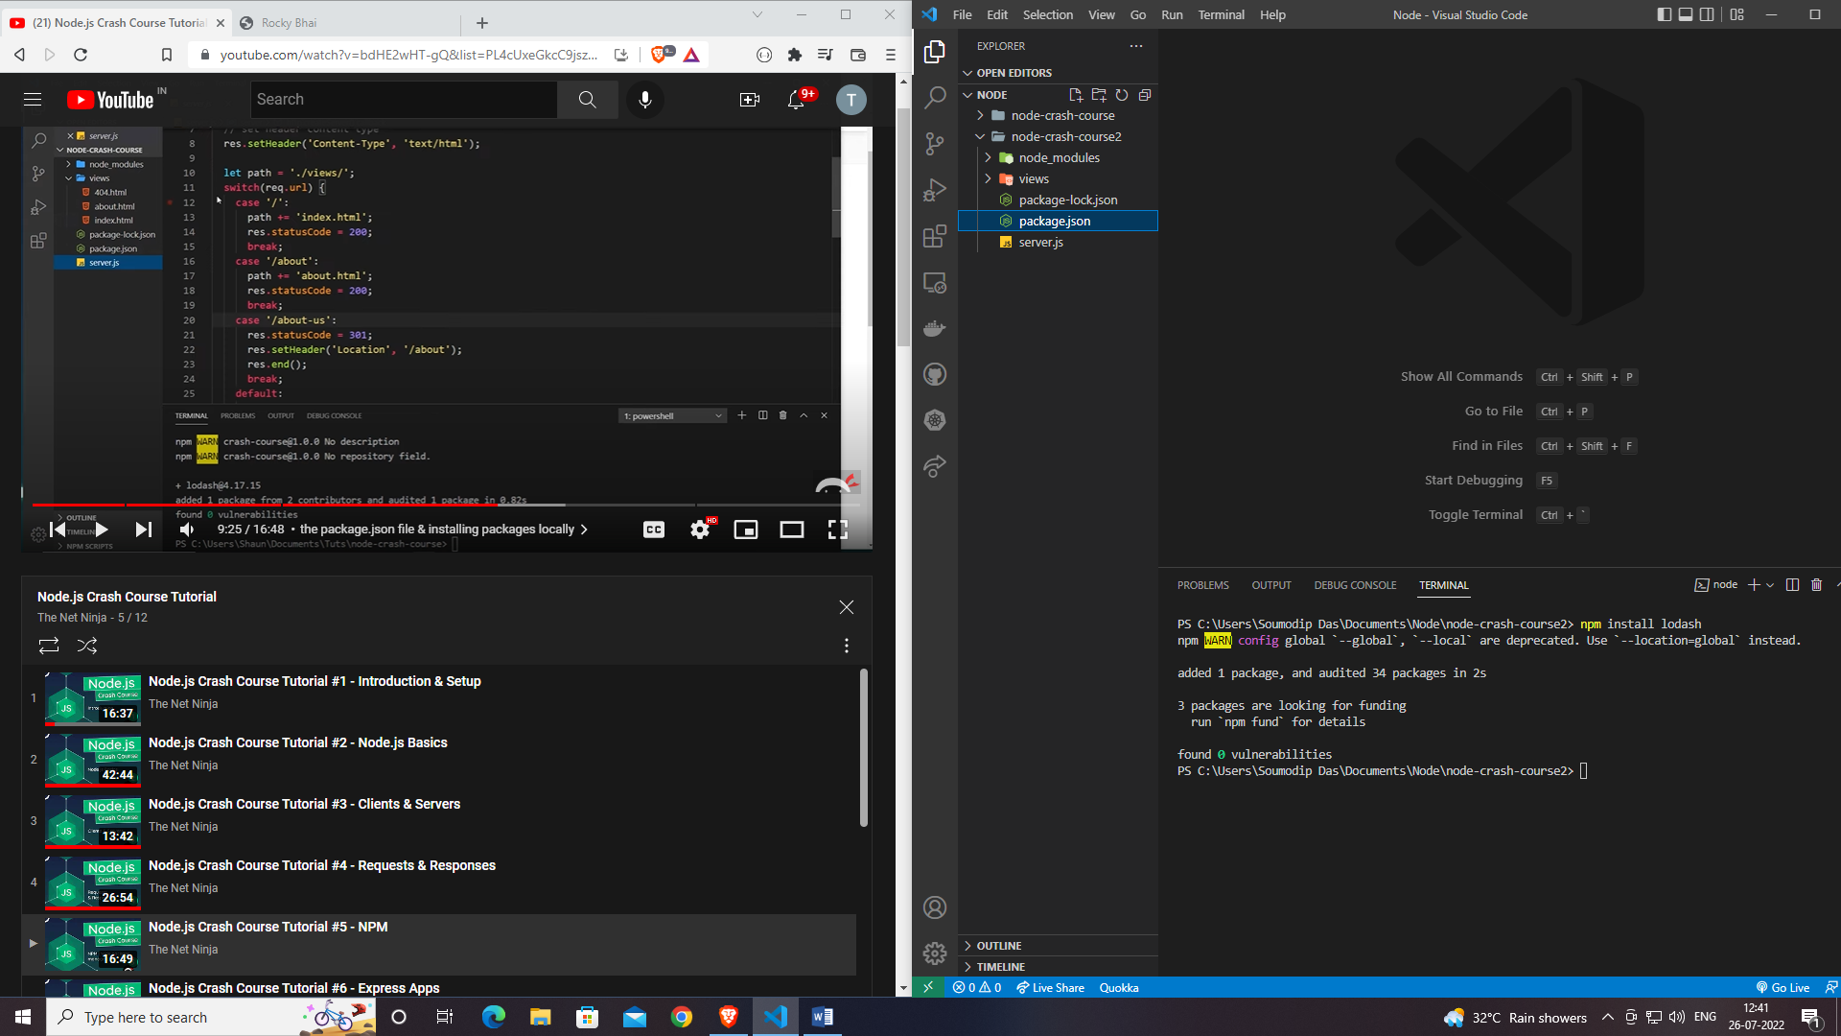

* **Installing lodash on system**

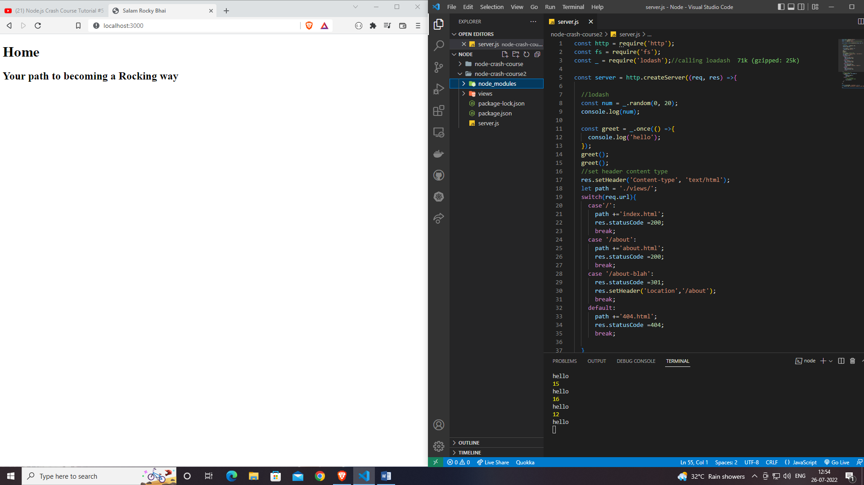

**Dependencies**

* **npm install – for installing node modules**
* **npm install -g nodemon – for installing nodemon**
* **npm init – for installing package.json file**